# Closed-loop experiments with CLoSES-RT

## Up Front Summary

* Get code from:
  + **CLoSES-RT**: Near real-time Closed-loop to Physiology

(<https://github.com/Center-For-Neurotechnology/CLoSES-RT.git>)

* Steps:
  1. Intracranial electrical brain signals from NSPs or acquisition boards are acquired,
  2. Bipolar or Referential montage,
  3. Band pass filtered,
  4. Features (power or coherence) continuously computed.
  5. If features are above (below) threshold for certain duration, stimulation is triggered.
* Key characteristics:
  + Thresholds are updated periodically, based on triggers, or fixed and modified on real-time.
  + Stimulation could occur following detection, after delay, or at trigger.
  + If decoded state is above (below) threshold, stimulation occurs on following trial.
* It is possible to configure random stimulation, which percentage of detections produce stimulation,
* Safety characteristics include a block period at the beginning and refractory periods after each stimulation.
* It runs on a dedicated Simulink Real-Time *target* computer with a GUI on another *host* computer for configuration and real-time visualization.
* It runs in parallel to clinical and research systems.
* Replay of previously acquired datasets allows feature selection and parameter optimization.

# Hardware & Connections in the EMU

## Non-Stim day hardware & connections – with BlackRock NSP acquisition

* USB labeled CLoSES (connected to CLoSES computer in patient’s room).
* If tasks:
  + Presentation computer with task
  + Connect **image onset trigger** (CHANNEL 2 from Presentation Octopus) from presentation computer to NSP **AINP3** (corresponds to channel 131 on CLoSES GUI).
* Connect **channel 1** of octopus from CLoSES to **AINP2** (to have “Stimulation” on NSX file)
* Connect **channel 2-5** of octopus from CLoSES to **AINP4-7** (to have “Detections” and “Random” events on NSX file)
* All connections should be split to NSP2.

## Stim day hardware & connections– with BlackRock NSP acquisition

* All of Non-Stim hardware & connections (above)
* Connect an octopus cable to parallel port cable from CLoSES computer (labelled CLoSES).
  + Connect **channel 1** of octopus from CLoSES to TRIGGER of Cerestim (this Triggers the Stimulation).
  + This BNC (Cerestim TRIGGER) should also be connected to NSP **AINP2**.
  + Connect the other channels to the other AINP inputs
* Stimulator (Cerestim)
  + Check connections (Headbox, power cord, and blue cables).
  + USB from Cerestim connected to Presentation computer or another to config.
  + SYNC output connected to **AINP1**
  + CHECK that **TRIGGER** is connected to Octopus **channel 1 from CLoSES** and to **AINP2**

# Running CLoSES-RT in the EMU

**Configuring CLoSES and GUI:**

* To Start CLoSES:
  + Connect USB key (black with label: CLoSES) to CLoSES target computer.
  + Turn on CLoSES. (Black screen with “Simulink” on the bottom should appear on small monitor on front of CLoSES).
* On HOST computer (BlackRock Computer):
  + Open MATLAB 2016b
  + Go to …\MATLAB\CLoSES\CLoSES-RT (see below)
* In runClosedLoopPhysiology.m edit participant name
* Run runClosedLoopPhysiology.m
  + Alternatively:
* CLoSES-RT to your path (right click on folder CLoSES-RT and select Add to Path with SubFolders).
* Type: GUIClosedLoopConsole(‘PatientName’,**’MGxxx’**)
* RECOMMENDED change directory where data is saved: GUINeuralDecoderClosedLoopConsole('PatientName','**MGxxx**','dirResults','D:\DeciderData\**MGxxx**')

# Running CLoSES-RT in Replay

CLoSES-RT can run on your Windows computer to replay data previously acquired.

**Running CLoSES-RT:**

* + Open MATLAB 2016b
  + Go to …\MATLAB\CLoSES\CLoSES-RT (see below)
* In runClosedLoopPhysiology.m edit participant name
* Run runClosedLoopPhysiology.m
  + Alternatively:
* CLoSES-RT to your path (right click on folder CLoSES-RT and select Add to Path with SubFolders).
* Type: GUIClosedLoopConsole(‘PatientName’,**’MGxxx’**)
* RECOMMENDED change directory where data is saved: GUINeuralDecoderClosedLoopConsole('PatientName','**MGxxx**','dirResults','D:\DeciderData\**MGxxx**')

# Operating CLoSES-RT GUI

**On Initialization screen:**

* + Keep drop-down menu as Continuous
  + Click on *Load Model* and look for MODEL file to load Simulink model (CLoSES-RT\CompileFiles*ClosedLoopStimXpcTarget.dlm*)
* NOTE: the first time you need to compile the model by opening ClosedLoopStimXpcTarget.slx in matlab
  + If you want to load pre-determined channels or other parameters:
* Click on *Configuration File* and look for configuration file (Default ones are on folder CLoSES-RT \Configuration)
* *Example: ConfigurationFile_IIDs_FixThreshold.m* for FIXED threshold and default IIDs configuration.
* Click on *Real-Time Closed-Loop* (to load main GUI) for operation in the EMU
* Click on *Simulation* (to load main GUI) for replay in your computer

**On CLoSES-RT GUI**:

* + On Channels Panel: Select *contacts* (bipolar channels correspond to left-right pairs of contacts in order (e.g. 1-2; 2-3 etc.)
* *NOTE: NSP2 channels start at channel 201 (e.g. NSP channel 14 corresponds to channel 214 on CLoSES GUI)*

EXAMPLE:

* **BLOCK 1: Right selector: 232,233,234Left selector: 233,234,235**
  + **Right dACC- Channels RMF1-RMF2, channel numbers-: 232-233(NSP 2)**
  + **Right dACC- Channels RMF2-RMF3, channel numbers-: 233-234(NSP 2)**
  + **Right dACC- Channels RMF3-RMF4, channel numbers-: 234-235(NSP 2)**
* **BLOCK 2: Right selector: 27,28,29 Left selector: 28,29,30**
  + **Left dACC- Channels LMF1-LMF2, channel numbers-: 27-28 (NSP 1)**
  + **Left dACC- Channels LMF2-LMF3, channel numbers-: 28-29 (NSP 1)**
  + **Left dACC- Channels LMF3-LMF4, channel numbers-: 29-30 (NSP 1)**
* By Default, ALL features are selected as “Detection Channels/Pairs” to save all features.
* OPTIONAL: Select as Visualization channels only those in detection
* Other Options should be double checked (see also figure below):

EXAMPLE: for IIDs with stimulation with fixed Threshold:

* Filter: NoFilter
* Feature: SmoothBandPower
* Detector: Continuous
* Stim on: Real Time

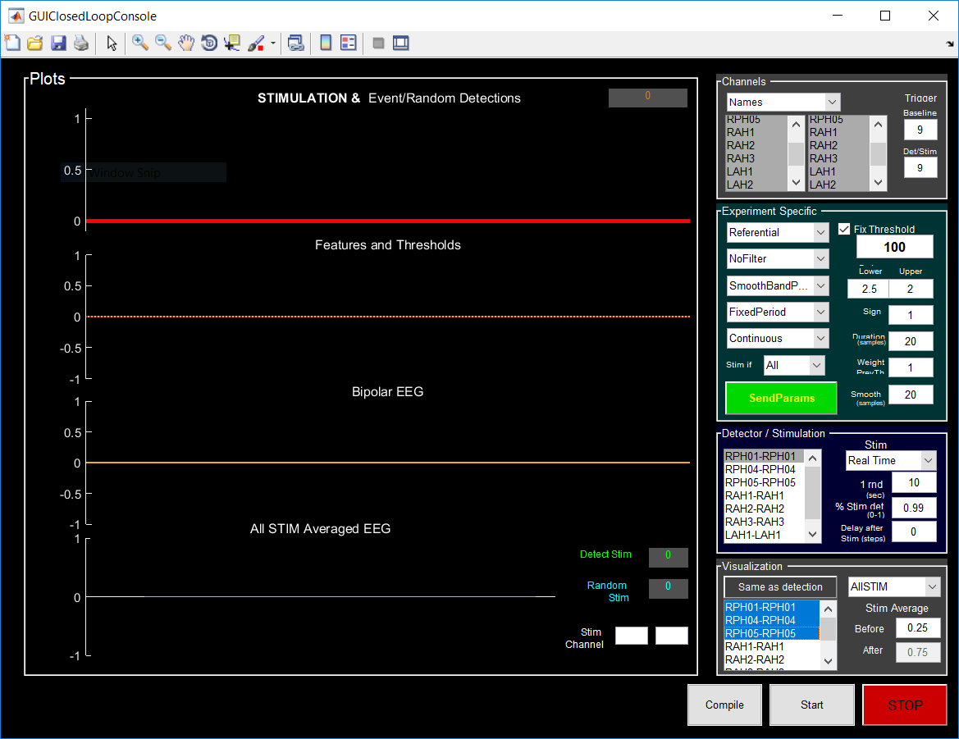

* Click on ***Compile***to Compile model (it will take 1-2min)
* Click on ***Start***to start Closed-Loop Stimulation System (it will compile if you didn’t press Compile)
* Click on ***Stop*** to stop and save file
  + - * + *There are 3 files: 1 for continuous data (EEG and stim), 1 for stimulation only data, 1 for performance information.*
        + *In addition, target backup files are transferred from Target computer (this are .dat files)*
        + Continuous Data File is called: DeciderData_EXPERIMENTTYPE_PATIENTNAME_DATE_TIME.mat

(e.g. DeciderData_IIDs_test_180426_0846.mat)

# When Running the CLoSES-RT GUI

* *Once started, you can change the threshold value, duration and number of random events* 
  + *Use SendParam to change the levels.*
* Stop – Start after each block to get separate files.
  + - * REMEMBER: Only saves data to files when STOP is pressed.

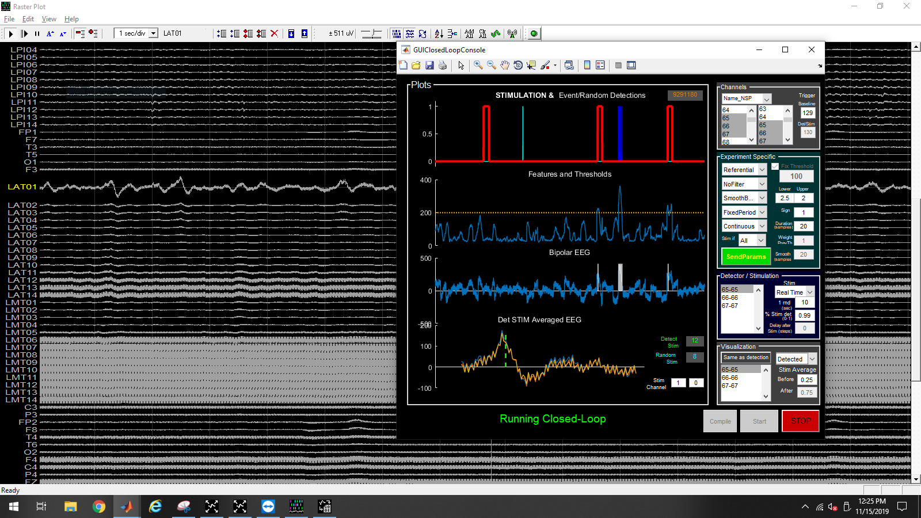

**Note:**  during simulation the channels names are read from the saved data. During real-time experiments channel numbers are used.

## Recover Data

* Data will be saved on Folder D:\DeciderData (or folder specified in ‘dirResults’,’DIRNAME’).
* Get the code from the components that generated the tasks and set up so that the code could be checked as to what it did per patient later
* Make sure to copy every file with today’s date on them (there will be 1 file per block)
  + Make sure to Stop/Start for each block

# Installing CLoSES-RT

Get Git bash: <http://msysgit.github.io/>

Go to the Github repository: <https://github.com/Center-For-Neurotechnology/CLoSES-RT.git>

Copy to Clipboard: <https://github.com/Center-For-Neurotechnology/CLoSES-RT.git>

To get the code, go to the directory you want to install things and clone the project (as from the site above)

Step by step:

1. Open GitHub bash (<http://msysgit.github.io/> or terminal on Linux/MAC)
2. Go to the directory where CLoSES-RT will be installed (**cd /D/MATLAB/CLoSES/CLoSES-RT**).
3. Type:

**git clone** [**https://github.com/Center-For-Neurotechnology/CLoSES-RT.git**](https://github.com/Center-For-Neurotechnology/CLoSES-RT.git) **.**  (the last dot means here).

## Updating CLoSES-RT code

To update the code, open git bash, go to the directory you installed things and type:

git pull

The first time you will be asked to relate your copy to origin. Follow instructions on screen.

If you are updating on a computer for simulations, that’s it!

# Compiling model for the first time

If you are updating the RIG, it is a good idea to compile model before running GUI (see screenshot below).

1. In MATLAB type:

initializationScript('REAL-TIME',[],'THETA','SMOOTHBANDPOWER','REALTIME','CONTINUOUS','EEGDATA')

1. Double-click on

CLoSES-RT\ClosedLoopStimulation\StateEstimateModel\ClosedLoopStimXpcTarget_WithDecoderModel.slx

1. Go to directory: **CompileFiles**
2. On model click the “Build model”
3. Get back to CLoSES root folder

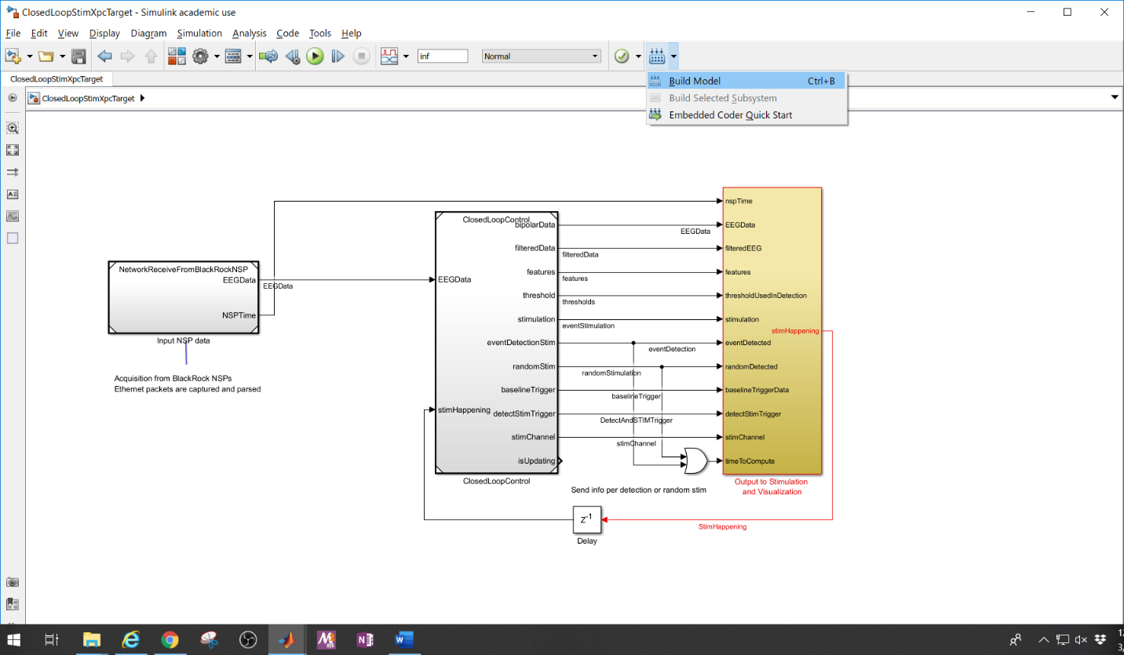

# Dependencies

MATLAB toolboxes:

* MATLAB
* Simulink
* Simulink Real-Time
* Signal Processing Toolbox
* Communications Toolbox
* DSP System Toolbox